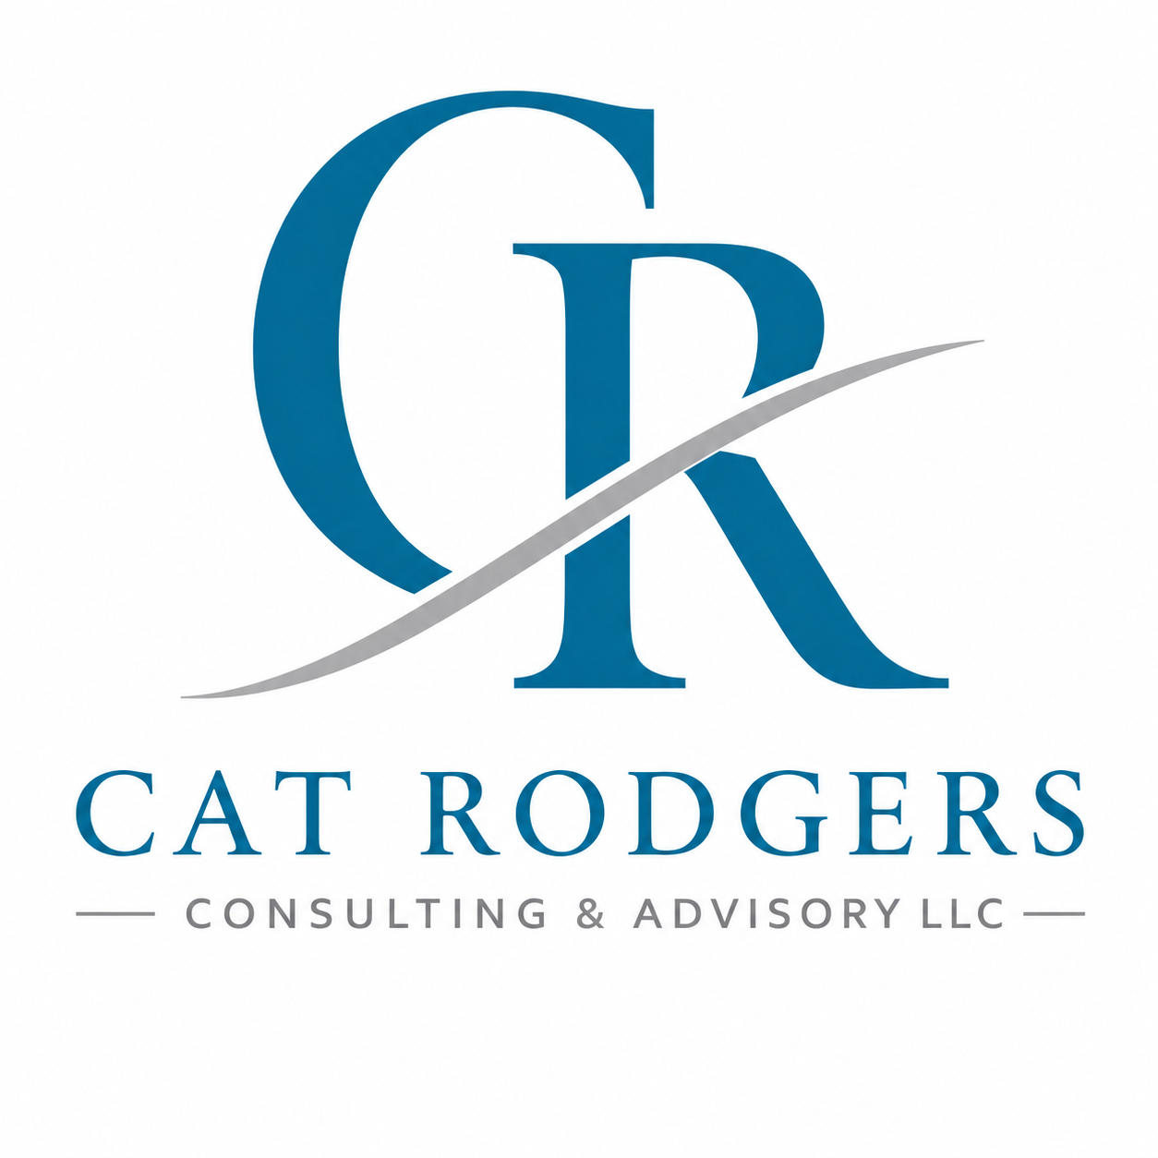
Professional Standards & Client Commitment

At Cat Rodgers Consulting & Advisory, every client relationship is built on trust, professionalism, integrity, and respect. My commitment is to provide thoughtful guidance, honest communication, and practical solutions that support sustainable growth, strong leadership, operational excellence, and positive client experiences.
Integrity First
I will always provide recommendations and guidance honestly, ethically, and in the best interest of the client organization or individual.
Confidentiality & Discretion
All client information, operational details, leadership discussions, financial information, and strategic conversations will be treated with professionalism and confidentiality unless disclosure is legally required.
Respectful Partnership
Every engagement will be approached with professionalism, empathy, collaboration, and mutual respect. Different perspectives, leadership styles, and organizational cultures are valued.
Client-Centered Solutions
My recommendations are designed to align with each client’s goals, operational realities, budget considerations, and organizational values. I do not believe in a “one-size-fits-all” approach.
Transparency & Communication
I am committed to maintaining clear communication regarding scope, timelines, deliverables, and fees throughout each engagement. Any concerns, delays, or changes will be communicated promptly.

Professional Excellence
Services will be delivered with preparation, accountability, attention to detail, and a commitment to continuous professional development and industry best practices.
Conflict of Interest
Any potential conflicts of interest will be disclosed promptly. Client trust and objectivity will always remain a priority.
Respect for People & Culture
I believe a respectful and inclusive environment is essential to effective leadership and organizational success. All individuals will be treated professionally and fairly.
Collaborative Implementation
My recommendations are intended to support and empower clients in strengthening operations, leadership, employee engagement, and customer experience. Collaboration and partnership are encouraged throughout the process.

Client Partnership Expectations
To ensure the most effective consulting experience, clients are encouraged to:
- Provide timely and accurate information
- Communicate openly regarding goals and challenges
- Participate collaboratively in discussions and planning
- Designate appropriate decision-makers and contacts when applicable
- Respect agreed-upon timelines, payment terms, and project scope

My Mission
My mission is to help individuals, organizations, and businesses strengthen leadership, improve operational effectiveness, enhance customer and employee experiences, and build sustainable long-term success through ethical, practical, and people-focused consulting support.

